30/10/2026
Raised request for access to [unix.ncl.ac.uk] via the website [https://nuservice.ncl.ac.uk/HEAT/Modules/SelfService/#serviceCatalog]

31/10/2026
Previously raised request did not work
Raised request for access to unix.ncl.ac.uk via a form available on the website [https://services.ncl.ac.uk/itservice/technical-services/unix-time-sharing/] - needs 24h to activate

01/11/2026
Access to [unix.ncl.ac.uk] obtained
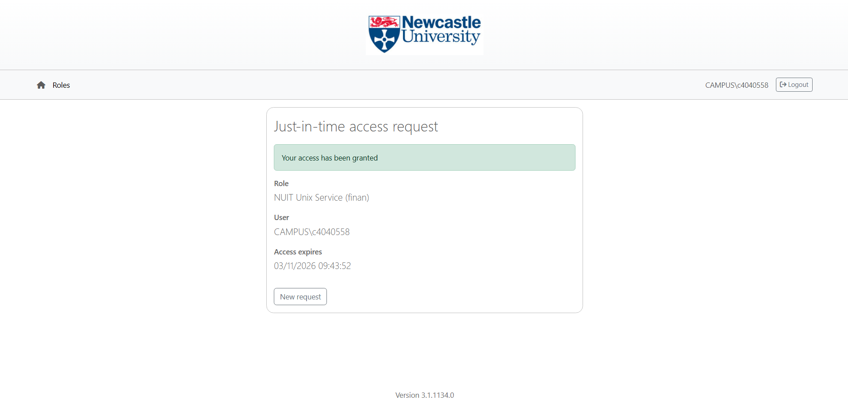
Tried connecting to MasterPi via ssh from command prompt
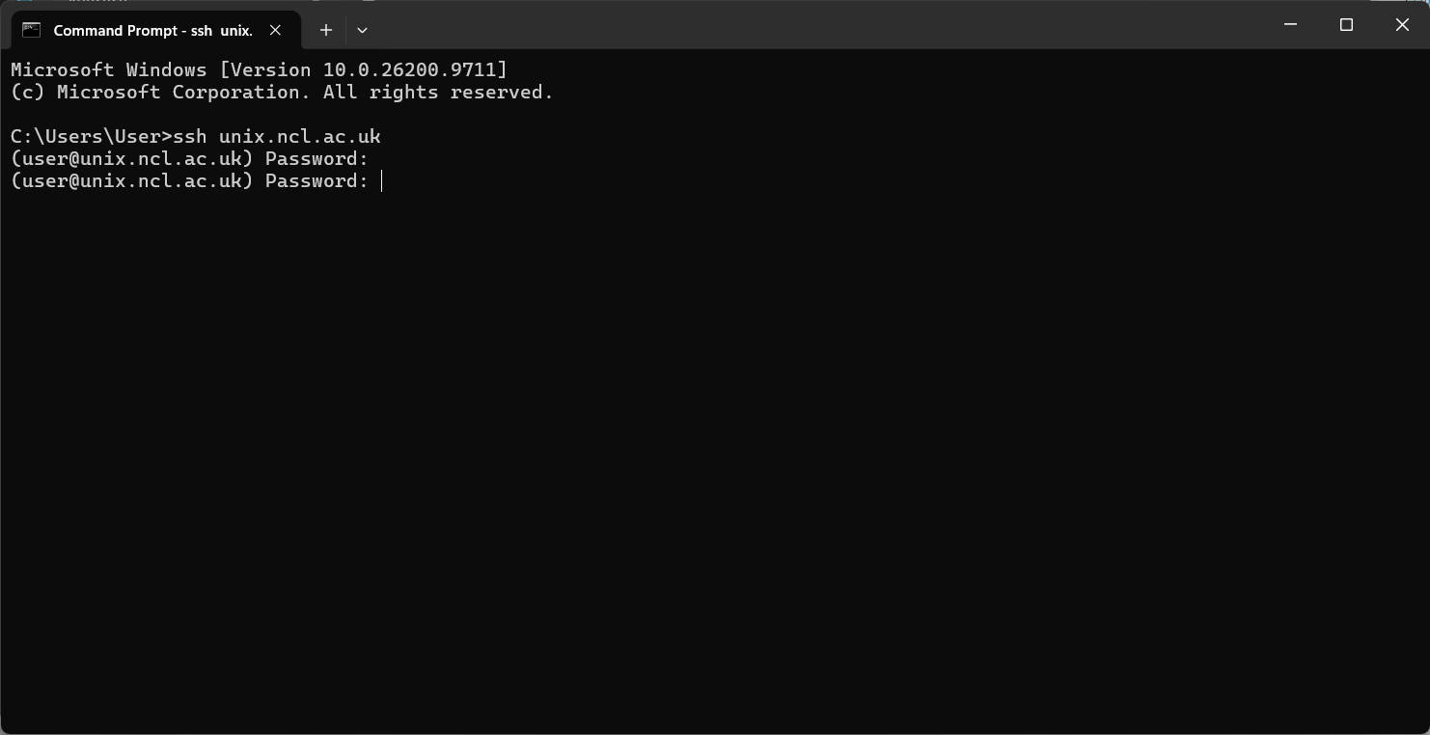
Failed to connect with [unix.ncl.ac.uk] – I needed to append username [login@unix.ncl.ac.uk]
Connected to [unix.ncl.ac.uk] server by using the right ssh id and university login password
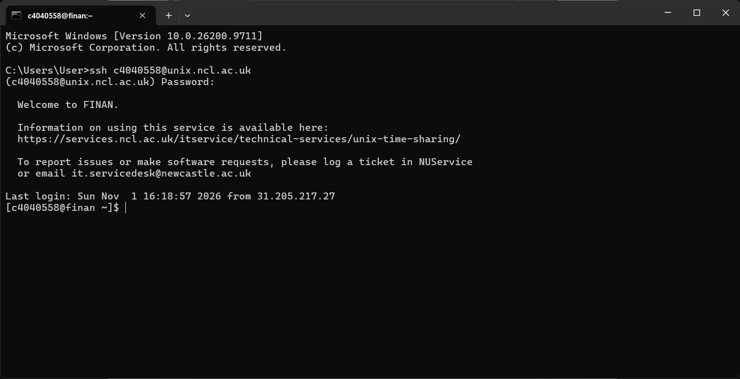
Tried connecting to ManagerPi3 [Group 3] via ssh
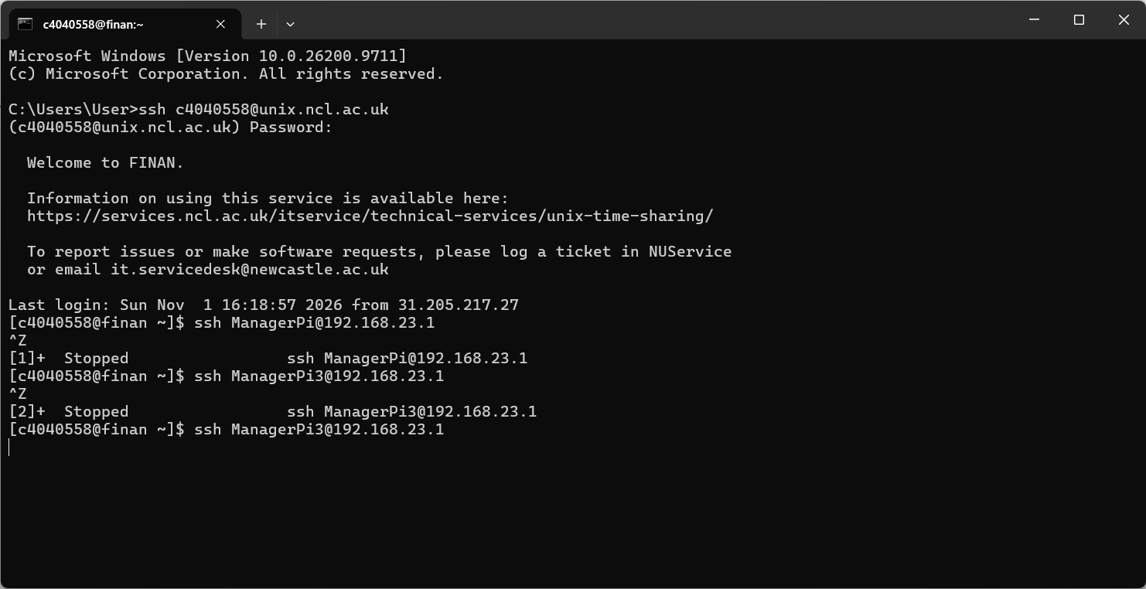
Failed – presumably because ssh keys were not generated and authenticated

02/11/2026
Downloaded PuTTY from Microsoft Store [https://apps.microsoft.com/detail/XPFNZKSKLBP7RJ?hl=en-US&gl=GB&ocid=pdpshare]
Connected to [unix.ncl.ac.uk] using PuTTY
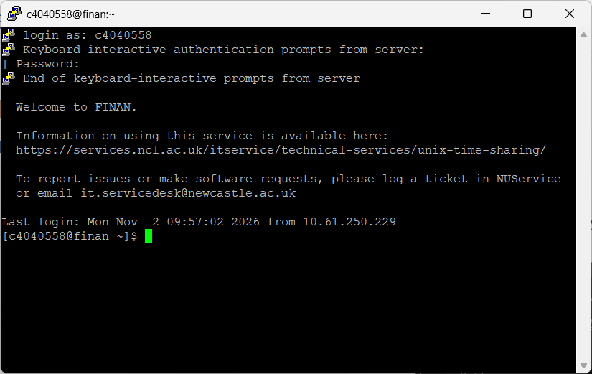
Generated ssh keys as per [Lecture 3 M2M with SSH-1.pdf - https://ncl.instructure.com/courses/70671/files/11087442?wrap=1] using [ssh-keygen]
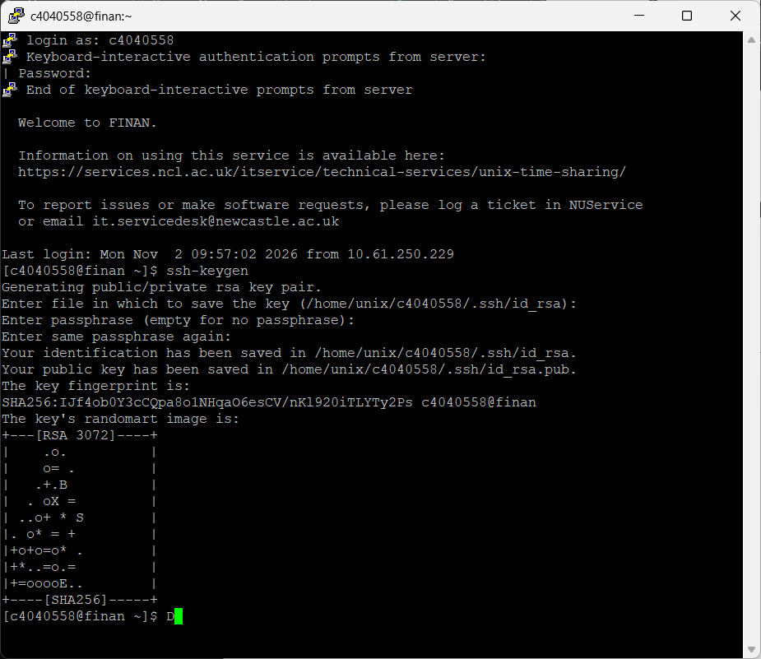
Passphrase left empty – as per instructions
Saved ID in [/home/unix/c4040558/.ssh/id_rsa]
Saved Public Key in [/home/unix/c4040558/.ssh/id_rsa.pub]
Connected to [ManagerPi3] after a few tries, following instructions as per [coursework1.pdf - https://ncl.instructure.com/courses/70671/files/11051635?wrap=1] using [ssh -Y -p 10322 c4040558@localhost]
Used ssh tunnels to try utilizing Local Port Forwarding to access video stream [ssh -L 10380:192.168.23.1:10380 c4040558@unix.ncl.ac.uk]
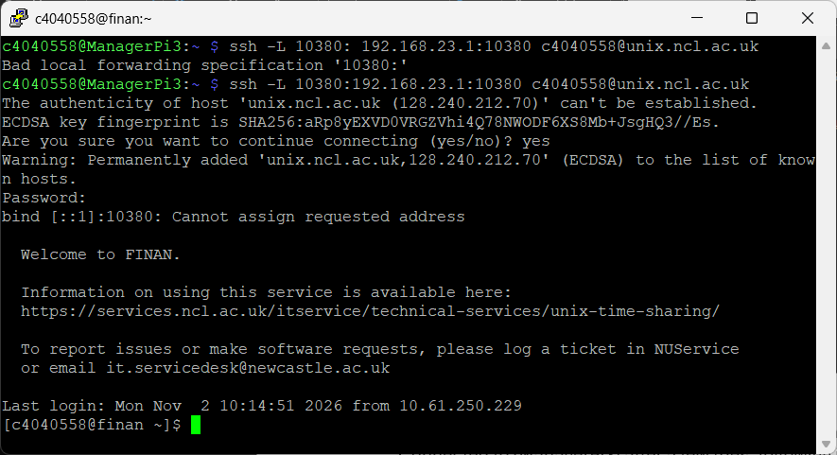
Failed with error in binding port addresses
Tried again while forcing IPv4 binding
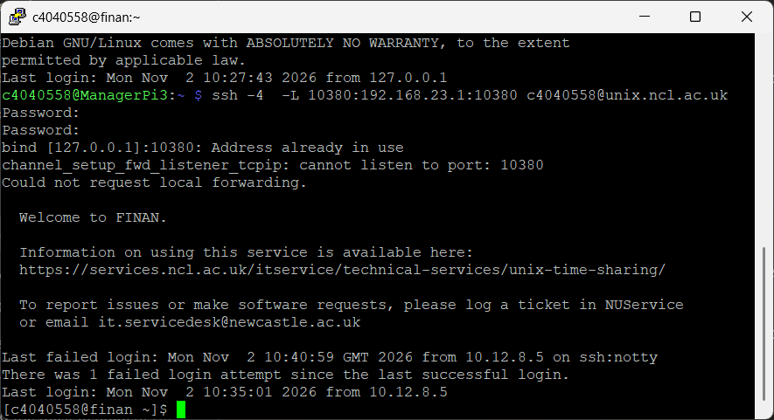
Failed with error in requesting local port forwarding – address already in use on local port
Used [netstat -ano] to find all ports in use
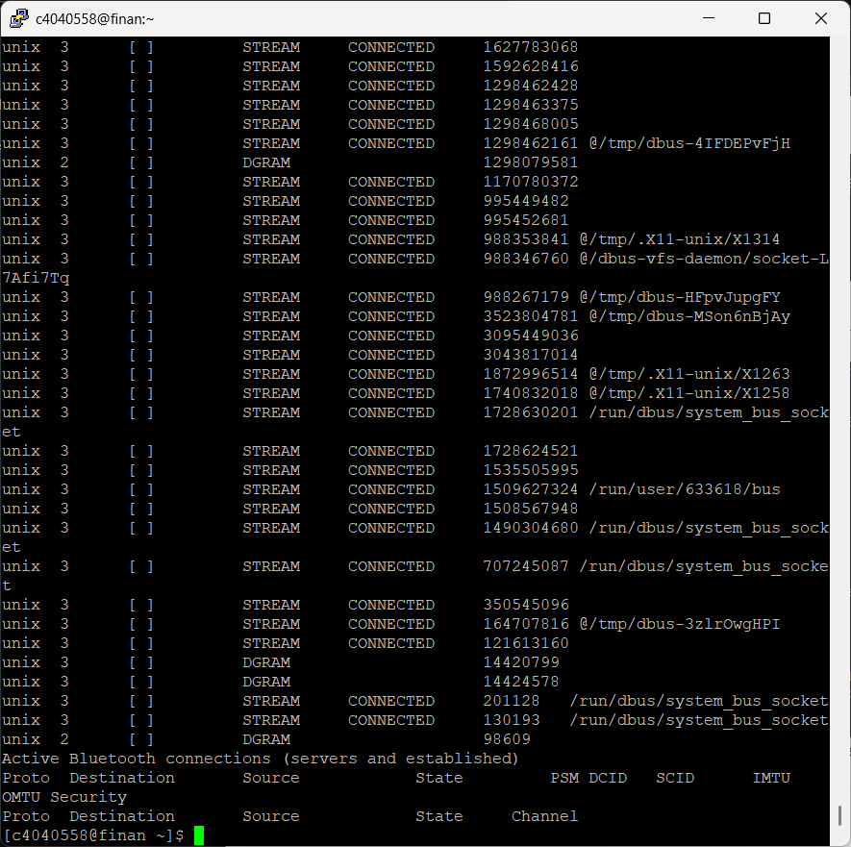
Checked for port [10380] on local machine – returned as occupied
Tried a higher address port [18080] on local machine – returned as free
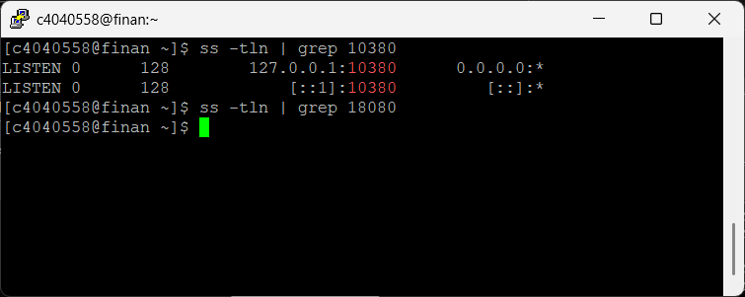
Considered using port [18080] for local port forwarding
Used ssh tunnels to try utilizing Local Port Forwarding to access video stream [ssh -L 18080:192.168.23.1:10380 c4040558@unix.ncl.ac.uk]
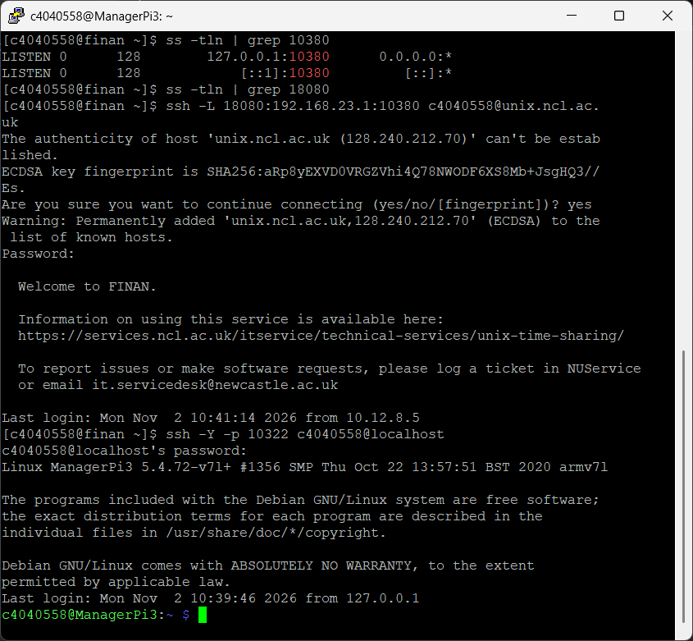
No error – got automatically logged out
Port was not successfully forwarded
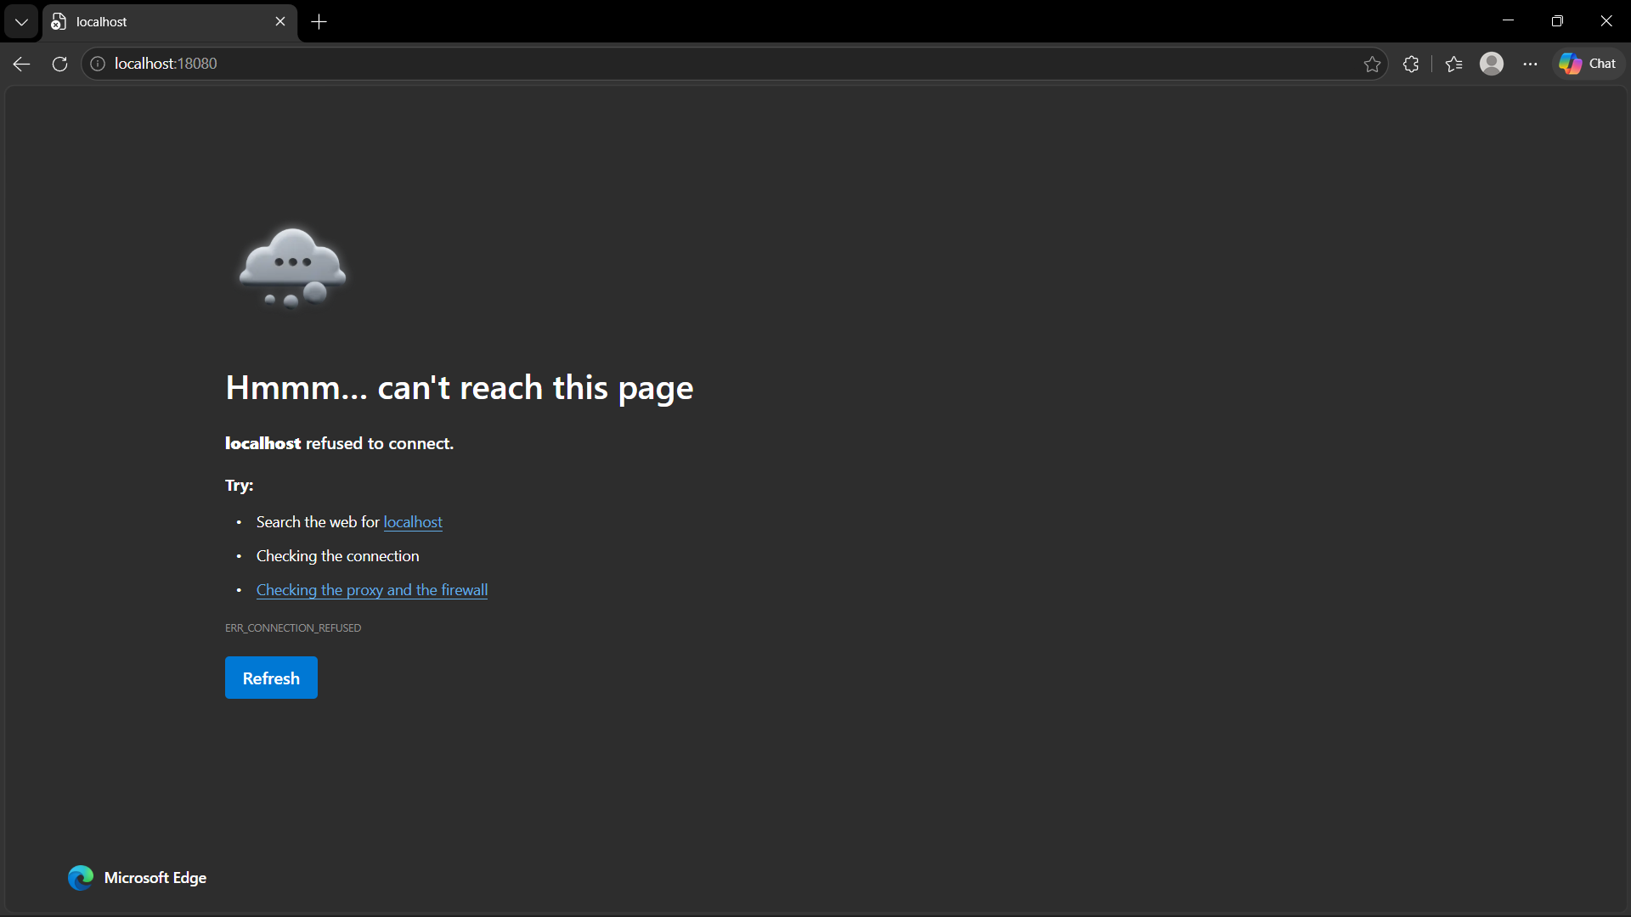
Fixed error – using the wrong hostname – switched to using [localhost]
Tried using [ssh - y -p 10322 -L 10380:192.168.23.1:10380 c4040558@localhost]
Also tried using [ssh - y -p 10380 -R 28080:192.168.23.1:10380 c4040558@localhost]
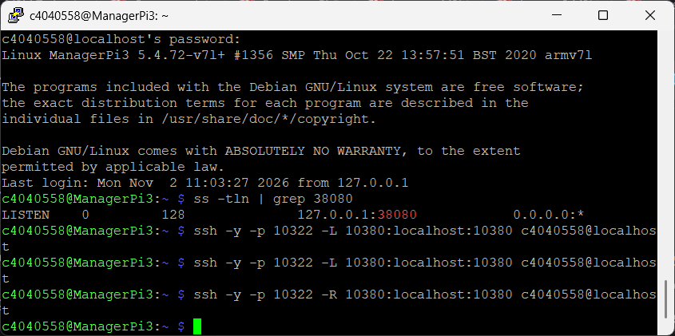
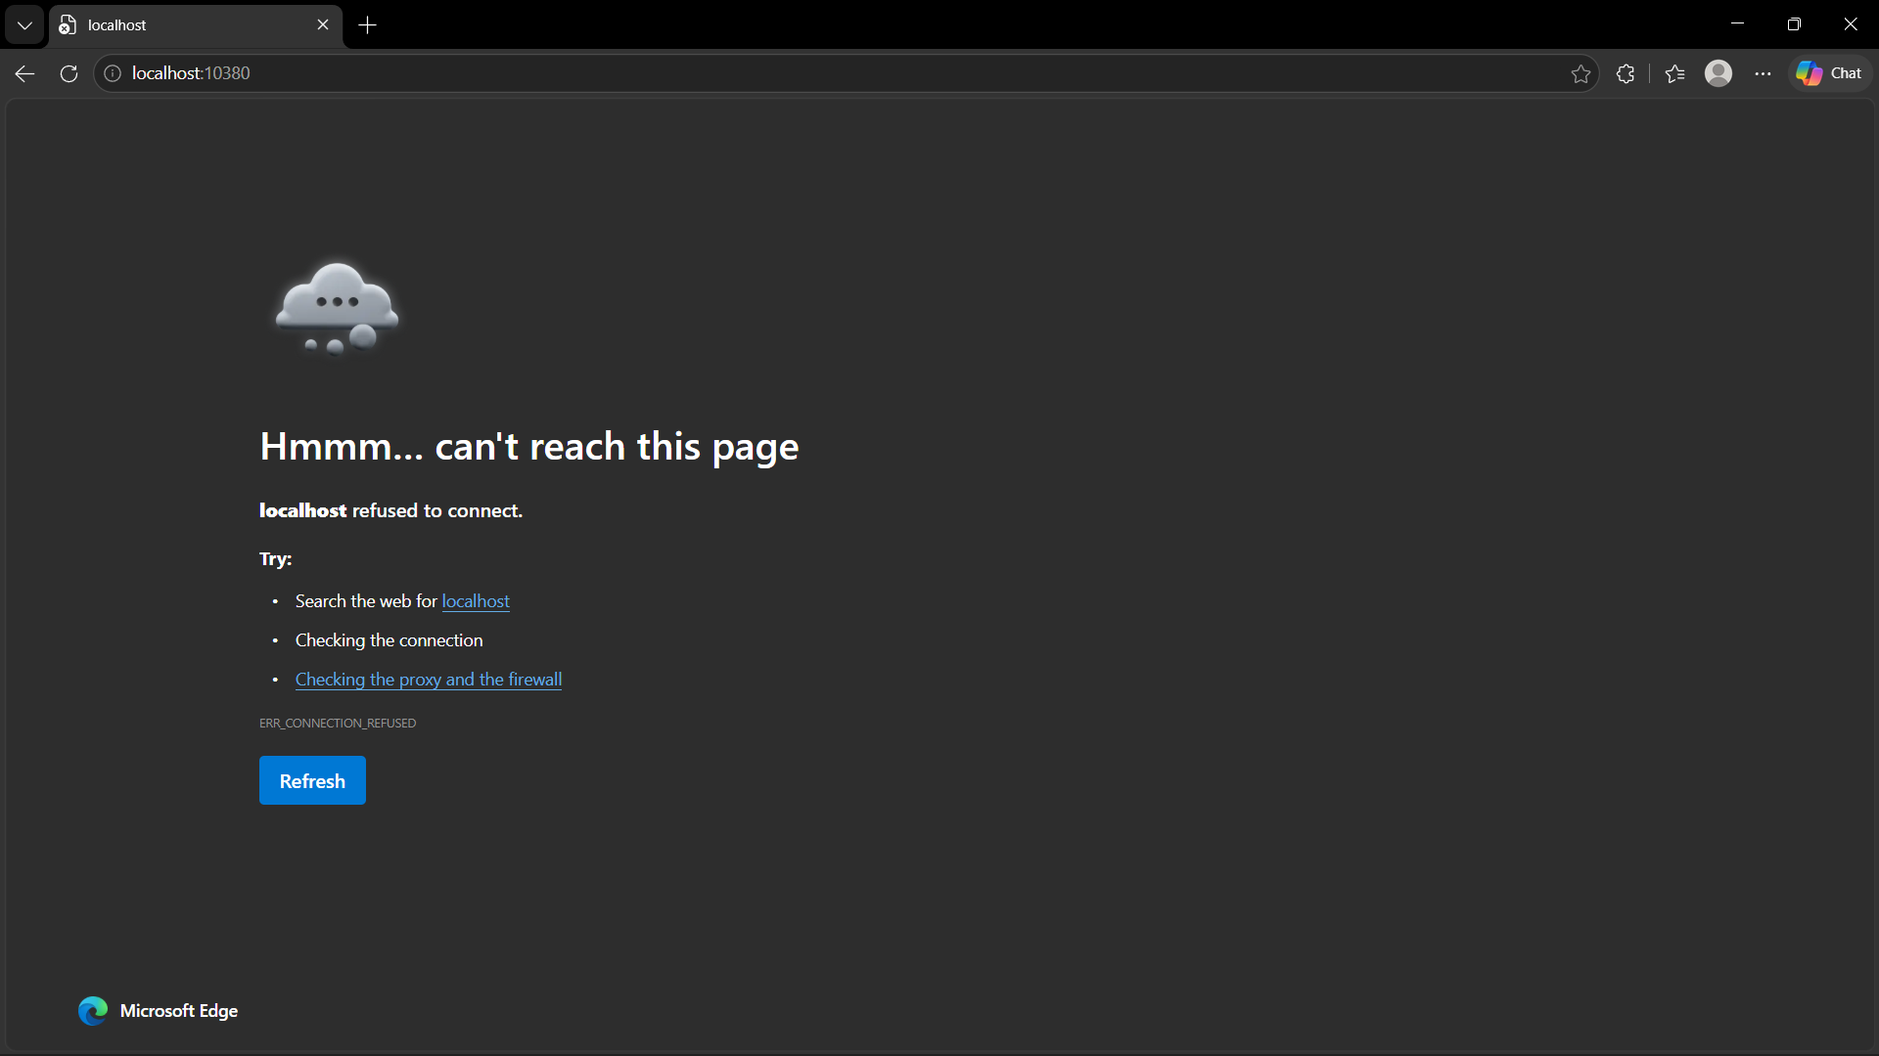
Failed both trials – no changes on browser – awaiting demo to understand this process before retrying – proceeding with other trials and necessities
Downloaded X2Go Client [https://wiki.x2go.org/doku.php/doc:installation:x2goclient]
Used [who], [ifconfig] and [route] on [ManagerPi3] to gather info
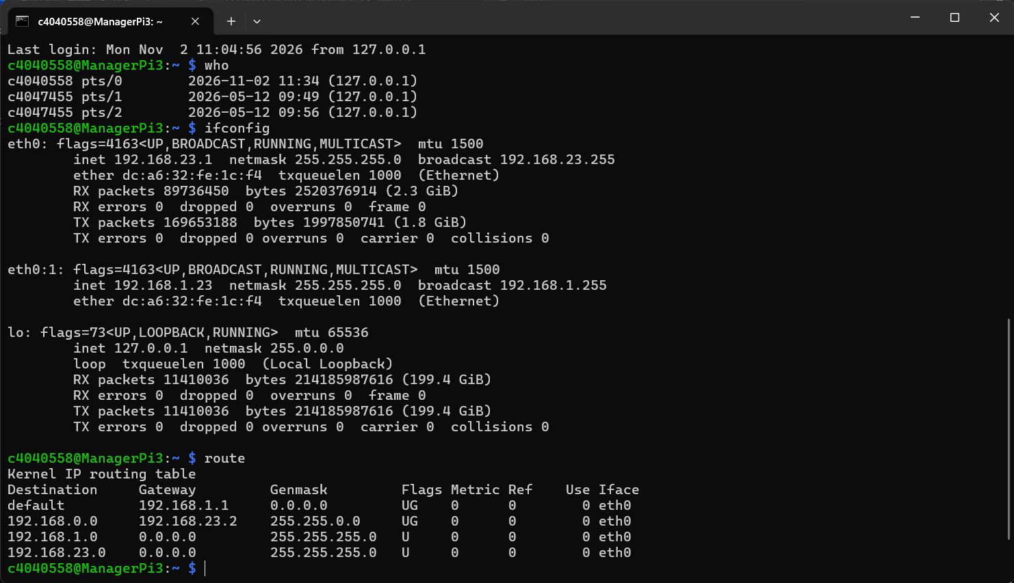
[default 0.0.0.0] – obtained by using [route -n] instead of [route]
Used [arp] and [ping localhost] on [ManagerPi3] for more info


